Work Done

1. Disabling Ipv6:

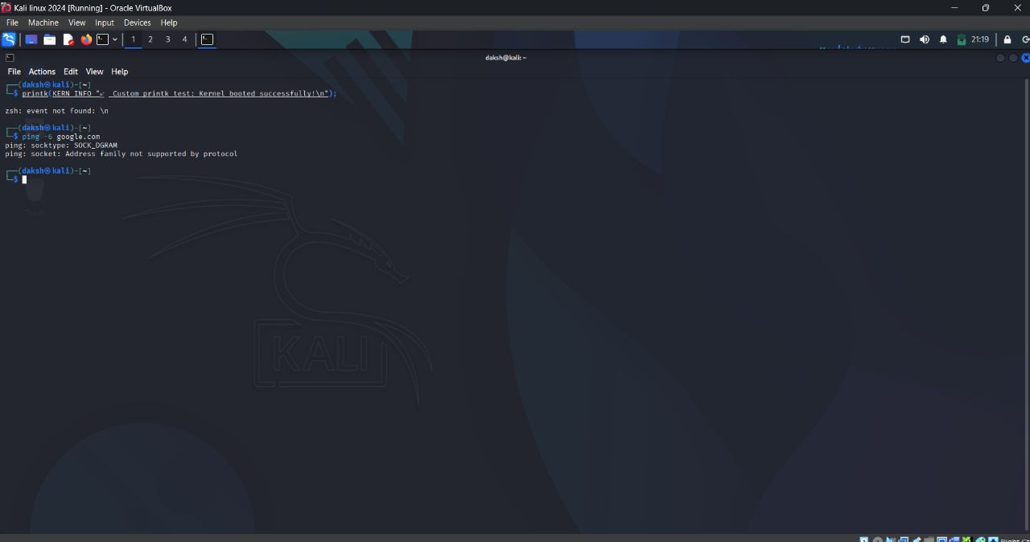

1. Custom Kali OS can detect USB devices(mouse) — but actual USB device isn't passed through to the VM:



1. Disbaling Bluetooth:



1. Disabling Sound: From the GRUB Menu we disabled the **sound card** of the Operating System

